MP-QUIC for Seamless Handover of Autonomous Mobile Robots in Heterogeneous Networks

Dohyeon Limª and Seok-Joo Koh^{b}
aDepartment of Data Convergence Computing, Kyungpook National University, Republic of Korea
^{b}School of Computer Science and Engineering, Kyungpook National University, Republic of Korea (corresponding author)

Abstract
Autonomous Mobile Robots (AMRs) in smart factories necessitate highly stable, low-entropy wireless communication for real-time control and monitoring. While ubiquitous, Wi-Fi infrastructure is susceptible to performance degradation during the frequent access point (AP) handovers inherent in mobile operations, which introduce severe latency spikes and transient disconnections. Conventional transport protocols, including single-path QUIC (SP-QUIC), are acutely vulnerable to these mobility-induced link failures, leading to costly connection recovery procedures and unacceptable service interruptions for mission-critical applications. To overcome this critical limitation, we propose a handover-adaptive multi-path QUIC (MP-QUIC) transmission scheme designed for heterogeneous wireless environments, concurrently leveraging Wi-Fi and 5G mobile networks. The core of our approach is a novel Path Quality Index (PQI) that enables the proactive detection of impending link degradation. This allows the system to trigger a lightweight, sub-second failover to a pre-established backup path, thereby circumventing the need for disruptive connection re-establishment. Experimental evaluations conducted on a real-world AMR testbed confirm the efficacy of the proposed MP-QUIC scheme in preventing service outages during AP handovers. In stark contrast to the catastrophic failures of traditional SP-QUIC, our method achieves a switching latency of less than 100 ms, maintains consistent application throughput, and significantly mitigates tail latency, even under severe cross-traffic congestion. In conclusion, this work delivers a highly resilient transport-layer solution that ensures seamless and dependable communication, a fundamental prerequisite for the safe and efficient operation of AMRs in dynamic industrial environments.

Keywords: Autonomous Mobile Robot (AMR), handover, QUIC, multi-path QUIC (MP-QUIC), Wi-Fi, 5G

- Introduction
Autonomous Mobile Robots (AMRs) have emerged as a pivotal component of industrial automation, transforming operations in smart factories, warehouses, and other large-scale indoor facilities [1]. Deployed for tasks ranging from material transportation to safety monitoring, their ability to operate continuously across multiple work zones is essential. Unlike fixed automation, AMRs navigate dynamic environments without predefined paths, offering unparalleled flexibility and adaptability. This operational agility makes them indispensable in industrial sites with frequently changing layouts, driving their rapid adoption across various domains [2].
Effective AMR operation is fundamentally dependent on robust, real-time communication. These robots continuously exchange a heterogeneous mix of data, ranging from low-latency control commands and localization updates to high-bandwidth sensor and video streams. Consequently, the communication requirements for AMRs are far more stringent than for conventional mobile devices. Even momentary lapses in connectivity can severely compromise navigation stability, delay task execution, and jeopardize safety responsiveness. Therefore, seamless connectivity and low-latency performance are not optional enhancements but fundamental prerequisites for reliable AMR operation [3].
Achieving this level of connectivity, however, is a significant challenge in large-scale indoor environments. The constant mobility of AMRs across the coverage areas of multiple Access Points (APs) makes handovers inevitable, a process notorious for degrading network performance [4]. To ensure robust and pervasive coverage, deployments typically utilize a heterogeneous wireless infrastructure, combining ubiquitous Wi-Fi with private cellular networks like 5G [5]. To extend coverage in large facilities, multiple APs and Wi-Fi mesh architectures are widely used [6, 7]. Nevertheless, Wi-Fi mesh does not fundamentally eliminate mobility-induced disruption at the client side. A mobile AMR remains associated with only one serving AP at a given time, and the AMR must switch to another AP as the quality of the current link deteriorates. Such transitions can produce temporary disconnections, increased latency, packet loss, and RTT fluctuations [8, 9]. Figure 1 illustrates a representative AP-boundary crossing scenario in which these effects can interrupt ongoing communication.

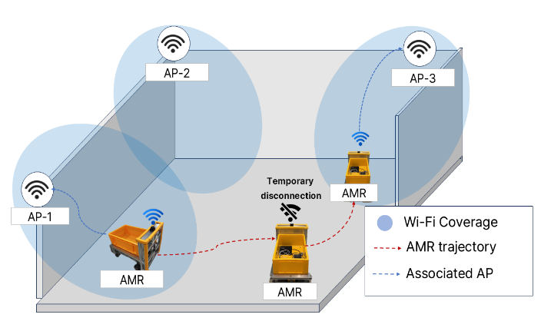
Figure 1: AP Handover Challenges for AMRs in Wi-Fi Networks

To address these mobility challenges, the QUIC protocol offers several advantageous features. As the transport foundation of HTTP/3, QUIC's support for Connection IDs (CIDs) is particularly salient. CIDs decouple a transport session from the underlying IP addresses, enabling seamless connection migration when network interfaces change—a critical feature for maintaining session continuity under mobility [10, 11]. The Multipath QUIC (MP-QUIC) extension builds upon this capability by enabling the concurrent use of multiple network paths within a single connection [12]. This is especially beneficial for AMRs operating in heterogeneous environments, where both Wi-Fi and 5G interfaces can coexist. With MP-QUIC, an alternative path (e.g., 5G) can remain active and ready to take over traffic when the primary path (e.g., Wi-Fi) degrades during a handover. This intrinsic ability to leverage path diversity makes MP-QUIC a natural and powerful candidate for solving the handover problem in AMR systems.
Despite its clear potential, the direct application of MP-QUIC to the specific problem of AMR handover continuity remains largely unexplored. Existing research on MP-QUIC has primarily focused on general mobility or optimizing aggregate throughput across paths [13]. However, the industrial AMR scenario presents a more nuanced challenge: predictable, yet disruptive, degradation events caused by frequent AP handovers in a heterogeneous Wi-Fi/5G landscape. In this context, the central problem is not merely the availability of multiple paths, but the intelligent and timely utilization of them. Simply having a backup path is insufficient if the switchover is reactive, occurring only after significant service disruption has already begun. Effective handover mitigation requires a proactive strategy: one that can anticipate link degradation on the primary path and steer traffic preemptively before a catastrophic failure occurs. Indeed, prior work in related domains confirms that proactive path sensing and preemptive switching are critical for maintaining seamless connectivity [14, 15]
To bridge this gap, this paper introduces a handover-adaptive MP-QUIC transmission scheme designed specifically for AMRs in heterogeneous Wi-Fi/5G environments. Our approach is founded on a key principle, “to not merely use multiple paths, but to exploit them in a handover-aware manner.” The core of our scheme is a novel metric we term the Path Quality Index (PQI). This index is designed to proactively detect the onset of Wi-Fi link degradation that precedes a handover. Upon detection, our scheme preemptively offloads traffic to the stable 5G backup path, effectively creating a seamless failover before the primary path fails completely. Once the Wi-Fi handover is complete and the link has stabilized, traffic is seamlessly migrated back to the preferred Wi-Fi path. This proactive, PQI-driven mechanism is designed to virtually eliminate service interruptions and suppress the transient performance degradation inherent to AMR mobility.
The main contributions of this paper are summarized as follows:
• The design of a novel, handover-adaptive MP-QUIC scheme that leverages a Path Quality Index (PQI) for proactive link degradation detection and seamless traffic offloading;
• The implementation and empirical validation of this scheme on a real-world AMR testbed, demonstrating its practical feasibility in a heterogeneous Wi-Fi/5G environment; and
• A comprehensive performance evaluation showing that our approach virtually eliminates service outages and significantly mitigates tail latency during handovers, outperforming conventional single-path transport.

- Related Works

  - Autonomous Mobile Robot
Autonomous Mobile Robots (AMRs) now form the operational backbone of modern smart manufacturing and logistics, prized for their ability to navigate highly dynamic industrial environments. Their defining advantage over traditional fixed or track-guided automation is this capacity for unconstrained mobility, which enables true operational agility across expansive facilities. However, this autonomy is critically dependent on wireless connectivity with stringent Quality of Service (QoS). To execute real-time motion control, coordinate with fleets, and safely avoid obstacles, AMRs demand ultra-low latency and deterministic reliability [16, 17]. The challenge is compounded by their heterogeneous traffic profiles, as they must concurrently transmit time-sensitive kinematic commands, high-frequency sensor telemetry, and bandwidth-intensive video streams. Consequently, the stability of this communication link is not merely a performance metric; it is a direct determinant of both operational efficiency and the physical safety of the human-robot collaborative workspace.
Despite these stringent requirements, the very nature of AMR mobility is fundamentally at odds with the architecture of conventional Wi-Fi. The need for continuous movement inevitably triggers frequent handovers between Access Points (APs). This inherent challenge is severely amplified within the harsh radio environment of industrial sites, which are characterized by metallic structures, moving machinery, and dynamic occlusions that cause severe multipath fading and signal attenuation [18]. Consequently, during an AP boundary crossing, the handover process itself becomes a significant source of disruption. AMRs are prone to prolonged re-authentication delays or the "sticky client" phenomenon, where they cling to a distant AP with a degraded signal. The immediate results are catastrophic: severe latency jitter, bursts of packet loss, and crippling RTT spikes. For an AMR, these are not minor glitches; they are transient failures that can instantly destabilize its closed-loop control systems, leading to erratic behavior or a complete stall of mission-critical operations.
As a remedy for the mobility-induced limitations of Wi-Fi, Private 5G Standalone (SA) networks have emerged as a promising alternative. Operating in dedicated spectrum with tightly controlled radio resource management, Private 5G provides superior coverage and resilience against the signal fluctuations common in mobile scenarios [19]. However, the predominant focus of existing AMR communication research, even within the 5G context, has been disproportionately centered on physical- and network-layer optimizations. Studies have concentrated on metrics like Radio Signal Strength (RSS), Signal-to-Noise Ratio (SNR), and link-layer throughput. While undeniably important, these lower-layer enhancements do not address the fundamental challenge of transport-layer session continuity. A robust radio link is a necessary, but not sufficient, condition for seamless application performance; the transport protocol itself must be resilient to the underlying network dynamics.
The crux of the problem lies at the transport layer, where protocols like TCP are fundamentally blind to the distinction between mobility and genuine network congestion. When an AMR executes a vertical handover (e.g., Wi-Fi to 5G) or traverses a signal dead zone, the underlying network changes are inevitable. From TCP's perspective, however, the resulting packet delays or losses are indistinguishable from congestion. This critical misdiagnosis triggers a catastrophic, yet entirely unnecessary, response: the protocol invokes punitive congestion control mechanisms, drastically cutting its sending rate, or drops the connection altogether. For the AMR's applications, the end-to-end service is shattered. Video feeds suffer jarring stalls, and, more critically, the control loop experiences latency spikes that can destabilize the robot's physical state. This demonstrates that optimizing lower-layer handovers alone is a fundamentally incomplete solution. Achieving true operational resilience, therefore, is not a question of optimizing the wireless medium alone; it is a question of architectural design. A proactive transport layer is the cornerstone of this design, serving as the essential abstraction layer that shields mission-critical applications from the inherent volatility of the wireless world.
  - QUIC and MP-QUIC

Standardized by the IETF, QUIC is a next-generation transport protocol, engineered over UDP to deliver secure, low-latency, and reliable communication [20]. It represents a fundamental departure from TCP's decades-old architecture. Whereas TCP identifies connections using a rigid 4-tuple (source/destination IP and port) and processes data as a monolithic byte stream, QUIC reimagines this structure entirely. A key innovation is the integration of transport logic with TLS 1.3 cryptography, unifying them into a single, streamlined protocol. This fusion allows for 1-RTT or even 0-RTT connection establishment, drastically accelerating initial setup compared to TCP's multi-step handshake. Furthermore, QUIC introduces native support for multiplexed, independent streams. Each stream is flow-controlled separately, a design choice that decisively eliminates transport-level Head-of-Line (HoL) blocking. Consequently, a lost packet in a non-critical stream (e.g., a high-bandwidth video feed) no longer stalls the delivery of mission-critical data, such as real-time control commands, on parallel streams.
Crucially for mobile environments, QUIC builds upon these features with its most powerful asset: Connection ID (CID)-based session management. The CID acts as a stable, transport-layer identifier that is completely decoupled from the ephemeral IP addresses of the underlying network. This architectural separation is what grants QUIC its intrinsic support for seamless connection migration. When a mobile client moves between access networks and its IP address changes, it does not need to tear down and re-establish the entire session, as TCP would. Instead, it simply begins sending packets from the new IP address, presenting the same CID to assert its identity. The ongoing connection is preserved, and the client proves ownership of the new path via a fast, cryptographic path validation exchange [21]. While single-path mobility schemes like mQUIC [22] leverage this powerful capability, they remain fundamentally reactive. They can only initiate migration after a new network path becomes available, leaving them inherently vulnerable to the performance blackouts that occur during the handover process itself.
Multipath QUIC (MP-QUIC) transcends the reactive limitations of single-path transport by embracing a "make-before-break" principle. It extends the core QUIC architecture to aggregate multiple network paths (e.g., Wi-Fi and 5G) into a single logical connection, all unified under one Connection ID (CID) [23,24]. This path diversity enables a sender to actively and concurrently exploit heterogeneous wireless interfaces, such as simultaneous Wi-Fi and 5G links. Unlike conventional failover mechanisms that merely maintain a passive backup link, MP-QUIC structurally isolates the transport states for each participating interface. Crucially, it maintains independent packet number spaces, continuous Round Trip Time (RTT) estimations, and separate congestion control states (e.g., individual congestion windows) for each path[25]. This per-path state isolation is vital; it ensures that transient packet losses or severe congestion on a deteriorating Wi-Fi link do not erroneously throttle the transmission rate of the stable 5G link.
The packet scheduler is central to MP-QUIC's operation, dynamically routing packets based on real-time path metrics. By continuously monitoring a cryptographically active backup path, it can instantly redirect traffic at the packet level as soon as the primary link degrades. This preemptive traffic steering enables MP-QUIC to significantly bound tail latency, mitigate packet loss, and ensure seamless continuity without resorting to slower, reactive session recovery methods [26].
While MP-QUIC offers promise, its standard schedulers fail catastrophically during AMR handovers. An industrial Wi-Fi handover is a messy, prolonged process causing severe RTT spikes and packet loss [27, 28]. This creates extreme performance asymmetry between the degrading Wi-Fi link and a stable 5G link. A standard scheduler, unaware of the handover context, continues to send traffic down the failing path. This leads directly to receiver-side Head-of-Line (HoL) blocking, where fast 5G packets are stalled waiting for slow Wi-Fi packets, nullifying the benefits of multipath [29]. To prevent critical control-loop failures, an AMR-centric MP-QUIC implementation must therefore be handover-aware, equipped with a proactive mechanism to detect link degradation early and steer traffic away from the failing path.
- Proposed MP-QUIC Transmission for handover of AMRs
  - System Architecture and Overview

To ensure seamless communication for AMRs in dynamic industrial environments, we propose a handover-adaptive Multipath QUIC (MP-QUIC) architecture. Our design concurrently manages heterogeneous wireless paths, typically a primary Wi-Fi link and a secondary 5G link, within a single unified transport connection. A core principle of our approach is the maintenance of a persistent, dual-path state, which contrasts sharply with conventional single-path migration schemes. By keeping the backup path always active and ready, our design entirely bypasses the signaling overhead and connection recovery delays associated with reactive failovers during Wi-Fi Access Point (AP) handovers.
Figure 2 illustrates the target network model for our work. We consider a common industrial deployment where an AMR navigates across the coverage of multiple Wi-Fi APs, all while under the continuous umbrella of a private 5G cellular network. As the AMR crosses an AP boundary, its primary Wi-Fi link is expected to suffer from transient degradation or complete disconnection before it can re-associate with the next AP. In this scenario, the persistent wide-area connectivity of the 5G network provides an ideal, stable backup path. This heterogeneous Wi-Fi/5G environment is precisely the context that motivates our multipath transport mechanism, designed to maintain uninterrupted communication by intelligently exploiting this path diversity.

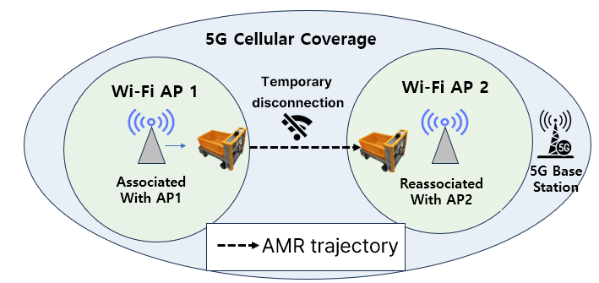
Figure 2: Network Model for AMR Handover in Heterogeneous Wi-Fi/5G Environments

Based on this network model, our proposed system architecture, depicted in Figure 3, is implemented as an intelligent, three-stage control pipeline: Sensing, Estimation, and Decision. This pipeline resides within the AMR and is designed to translate raw network signals into proactive routing actions.
The process begins in the Sensing module, which continuously ingests real-time network metrics (specifically ∆RTT and ∆Loss) derived directly from MP-QUIC’s acknowledgment stream. To overcome the physical disparities between Wi-Fi and 5G, the Estimation phase does not treat these raw, volatile metrics independently. Instead, it synthesizes them into a single, stabilized metric we term the Path Quality Index (PQI), employing trend analysis and Exponential Moving Average (EMA) filtering to smooth out momentary fluctuations.
This PQI then serves as the definitive input for the Decision module, which acts as the system's brain. Guided by the stable PQI value, this module executes critical, high-level routing policies over the underlying MP-QUIC transport. These policies include instantaneous failover upon degradation, hysteresis-based recovery to prevent path flapping, and optimal stream-to-path mapping. Ultimately, this tightly integrated architecture ensures that latency-sensitive application data is always routed over the optimal available path, effectively creating an abstraction layer that shields the remote server from the chaos of mobility-induced network events.

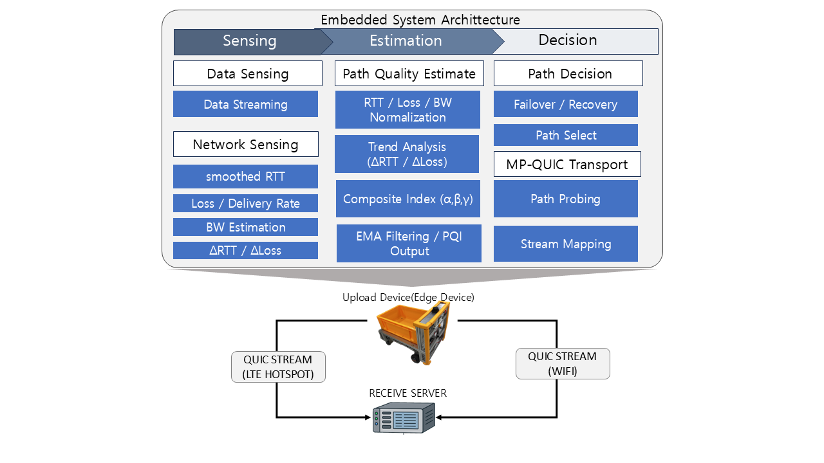
Figure 3: AMR-Embedded Proactive MP-QUIC Architecture: Sensing, Estimation, Decision Pipeline

  - Network Sensing and Metric Collection

The Sensing module continuously characterizes each active path by extracting key transport indicators directly from QUIC’s feedback mechanisms, as shown in Table 1. This early-warning system is designed to detect rapidly increasing latency or link instability before they impact AMR operations.
Table 1: Key Transport-Layer Indicators for Path Quality Assessment

Metrics | Description
RTT | Smoothed latency and variation trend
Loss rate | Burst loss and instability indicator
Throughput | Estimated available capacity
Congestion level | Inferred from retransmissions and delivery rate

The specific metrics are chosen to provide a multi-faceted view of path performance:
• Latency: Round-Trip Time (RTT) is continuously derived from QUIC’s acknowledgment (ACK) stream and smoothed via an Exponentially Weighted Moving Average (EWMA) to filter out spurious, short-term jitter.
• Reliability: The packet loss rate is calculated over a sliding window, diagnosing reliability issues from both explicit retransmission events and implicit signals like missing ACKs.
• Capacity: Available throughput is dynamically estimated by measuring the rate of acknowledged data delivery over time.
• Congestion: The overall path congestion state is inferred not just from loss, but from a combination of persistent retransmissions and any corresponding drop in the delivery rate, indicating a more systemic bottleneck.

  - Path Quality Estimation

To translate the raw metrics collected during the Sensing phase into actionable routing decisions, the system formulates a Path Quality Index (PQI). Because heterogeneous interfaces inherently exhibit different absolute performance ranges, evaluating them directly is ineffective. Therefore, the Estimation module adopts a min-max normalization within a sliding window, allowing for a fair mathematical comparison across the disparate paths.
Under normal operating conditions, the system evaluates the available paths using a cost-based path selection strategy. It calculates a composite cost function for each path $p$ by aggregating the normalized latency ($\hat{rtt_{p}}$), packet loss ($\hat{loss_{p}}$), and inverse bandwidth ($1-\hat{bw_{p}}$) as follows:
$$Cost_{p}=α⋅\hat{rtt_{p}}+β⋅\hat{loss_{p}}+ γ⋅(1-\hat{bw_{p}})$$
where $α$, $β$, and $γ$ represent tunable weights tailored to the application's specific requirements.
By continuously updating this cost function, the system maintains a stable and quantified real-time evaluation of each path's quality, laying the groundwork for the subsequent routing decisions.

  - Path Selection and Failover Scheduling

Based on the continuous evaluation from the Estimation phase, the path decision module determines the optimal active path for data transmission. While the scheduler actively maps traffic to the path $p^{*}$ that minimizes the aforementioned cost ($p^{*}=arg\min_{p}Cost_{p}$) during stable conditions, it must execute critical failover decisions when the AMR traverses AP boundaries.
Let $p_{a}$ be the currently active Wi-Fi path and $p^{*}$ be the 5G Mobile backup path. A rapid failover is explicitly triggered if the active path's PQI exceeds a predefined degradation threshold ($θ_{deg}$) and the backup path offers superior quality by a safety margin

$$Δ:PQI_{p_{a}}>θ_{deg} \text{and} PQI_{p^{*}}+Δ<PQI_{p_{a}}$$
This margin $Δ$ effectively prevents oscillatory switching. Furthermore, to guarantee long-term transmission stability, the decision module incorporates a stability-aware recovery mechanism. Even if the primary Wi-Fi path restores its signal strength, traffic is not immediately reverted. The system mandates that the recovered path maintain a satisfactory PQI below a certain threshold for a predefined stability interval ($T_{stable}$). This hysteresis logic is crucial for mitigating the "ping-pong" effect common in dynamic mobility scenarios.
Finally, to complement these sender-side routing decisions, all switching is governed by a frame-aware transmission controller. Aligning path transitions with video frame boundaries significantly reduces partial-frame loss. Concurrently, packets arriving via heterogeneous paths are timestamp aligned and reordered in a receiver-side buffer. This combined approach ensures stable video streaming and playback continuity for the AMR despite the underlying network handovers.
- Performance Evaluation by Experimentation
  - Testbed Configuration

Our experimental testbed was designed to emulate a realistic AMR deployment. The sender, an edge computer mounted on an AMR platform, was equipped with two heterogeneous wireless interfaces: a primary Wi-Fi interface connected to an indoor Access Point (AP) and a secondary 5G mobile hotspot for backup connectivity. The server-side receiver was connected via a dedicated wired Ethernet link to ensure that any observed performance degradation originated exclusively from the wireless access segment at the AMR side. To represent a typical remote monitoring use case, we transmitted a real-time 640x480 JPEG video stream from the AMR to the server.
For our performance comparison, we established two distinct transport configurations: (i) SP-QUIC, which exclusively utilizes the Wi-Fi path, and (ii) the proposed MP-QUIC scheme, which maintains both Wi-Fi and 5G Mobile paths and rapidly redirects traffic to the backup path during Wi-Fi degradation or disconnection. The objective of this comparison was to evaluate the effectiveness of multipath transport in preserving communication continuity during mobility-induced handover events.
To emulate the realistic movement of an AMR across AP boundaries, we designed three representative scenarios corresponding to the phases illustrated in Figure 4:
- Baseline: Stable Wi-Fi connectivity without any artificial network impairment;
- Wi-Fi Disconnection: A complete Wi-Fi outage, emulating temporary link loss or disassociation that may occur during an AP handover; and
- Wi-Fi Recovery: Restoration of Wi-Fi connectivity while the 5G Mobile backup path remains active, enabling the evaluation of traffic recovery and path reactivation behavior.

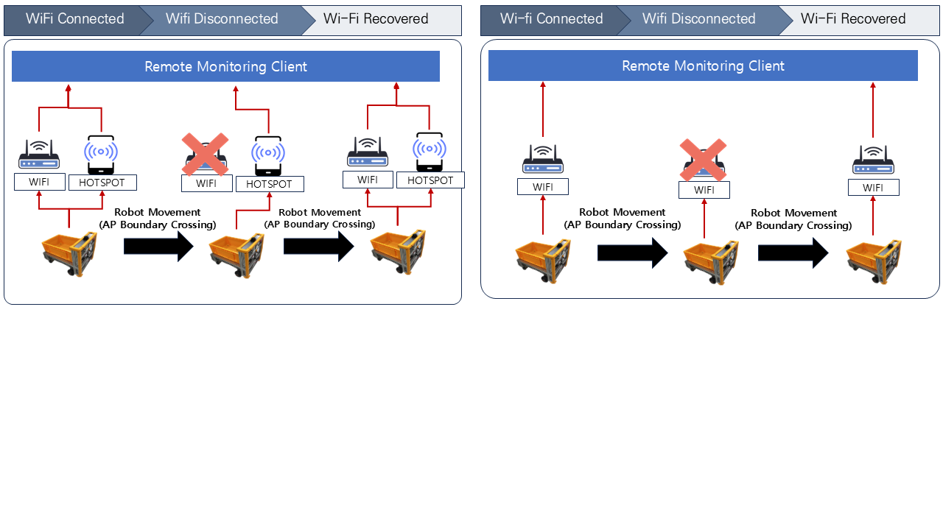
Figure 4: Handover Scenarios: (a) MP-QUIC with Wi-Fi and 5G, and (b) SP-QUIC with Wi-Fi only

Each scenario was repeated multiple times, and both representative results and averaged trends are reported to mitigate the impact of run-to-run variability. For the handover-focused analysis, we evaluated performance using the following indicators:
• Normal-state throughput: The application-level delivered bitrate under stable Wi-Fi conditions, used for the baseline comparison;
• Total transmission delay: The end-to-end transmission delay measured under different handover timings and congestion levels;
• Handover latency: The switching delay observed during Wi-Fi disconnection and recovery events;
• Congestion robustness: The variation in total transmission delay under increasing cross-traffic intensity; and
• End-to-end throughput continuity: The time-varying throughput behavior over the complete Wi-Fi disconnection-and-recovery cycle.

Additionally, a micro-level throughput analysis was conducted around the instants of Wi-Fi failure and recovery to capture short-term failover hesitation and rapid path reactivation behavior.
  - Results and Discussion
    - Summary of Performance Comparison

Before presenting a detailed analysis, we will first summarize the key performance distinctions between the standard SP-QUIC and our proposed MP-QUIC scheme. Table 2 offers a comparative overview of their behavior under both normal operating conditions and during handover events.
Table 2: Key Performance Comparison of MP-QUIC and SP-QUIC: Normal Operation and Handover Events
Category | Metric | SP-QUIC | MP-QUIC
Normal State | Throughput | 13.4 ~ 14.2 Mbps | 11.7 ~ 12.4 Mbps
 | RTT Stability | ∼ 50 ms | ∼ 52 ms
Handover | Switching Latency | Failure | 70 ~ 118 ms
Overall | Total Transmission Delay | 8,700 ~ 9,200 ms | 6,300 ~ 6,500 ms

As indicated in Table 2, SP-QUIC demonstrates marginally higher protocol efficiency and peak throughput (13.4 ~ 14.2 Mbps) in a stable Wi-Fi environment compared to MP-QUIC (11.7 ~ 12.4 Mbps). This slight reduction in performance is an anticipated and acceptable trade-off, arising from the inherent overhead of multipath scheduling and packet reordering mechanisms. The strategic value of this trade-off becomes evident during mobility-induced events. Upon handover, SP-QUIC suffers a complete link failure, leading to a total interruption of service. In stark contrast, the proposed MP-QUIC scheme seamlessly preserves the connection by executing a path switch with a latency of merely 70–118 ms, thereby containing the total transmission delay to within 6,300 ~ 6,500 ms.

    - Overall Throughput
The proposed MP-QUIC scheme excels at maintaining service continuity during Wi-Fi disconnection events by proactively leveraging a pre-established 5G Mobile backup path. While the primary Wi-Fi link delivers a stable throughput of approximately 14 Mbps under baseline conditions, its reliability is tested when the AMR crosses an AP boundary. At this critical juncture, the single-path architecture of SP-QUIC proves to be a significant liability; its throughput collapses to zero, resulting in a complete failure to preserve session continuity. In stark contrast, MP-QUIC gracefully redirects traffic to the 5G link, thereby sustaining a throughput of approximately 12.5 Mbps and preventing any service interruption.
The profound impact of this uninterrupted continuity is most dramatically reflected in the total transmission delay. As illustrated in Figure 5, which details the effect of handovers on delay, SP-QUIC incurs a massive latency penalty, regardless of the handover timing (e.g., at 300, 600, or 900 ms). The protocol's reliance on timeout and connection re-establishment procedures causes the total delay to skyrocket into the 8,700 ~ 9,200 ms range. Conversely, MP-QUIC effectively caps the total transmission delay at a consistent 6,300 ~ 6,500 ms across all tested scenarios. These results confirm that multipath transmission successfully bypasses the costly and time-consuming connection recovery phase, which is critical for ensuring the continuous monitoring and operation of AMRs.

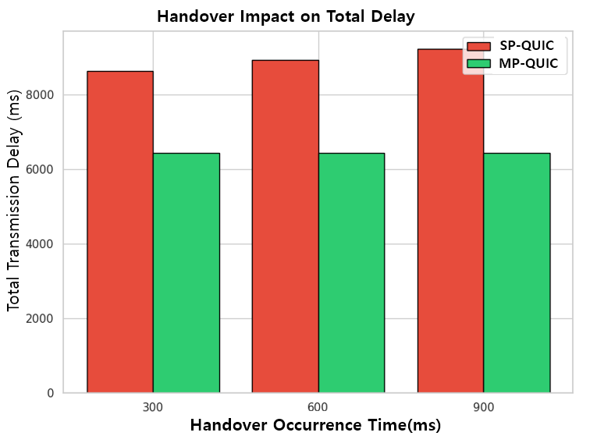

Figure 5: Analysis of Handover Impact on Total Transmission Delay for SP-QUIC and MP-QUIC

    - Handover latency

In addition to maintaining throughput, minimizing both handover latency and its variability under network congestion is important for reliable, real-time AMR control. Figure 6, which presents the distribution of handover latencies, illustrates the performance disparity between the two protocols in this regard.

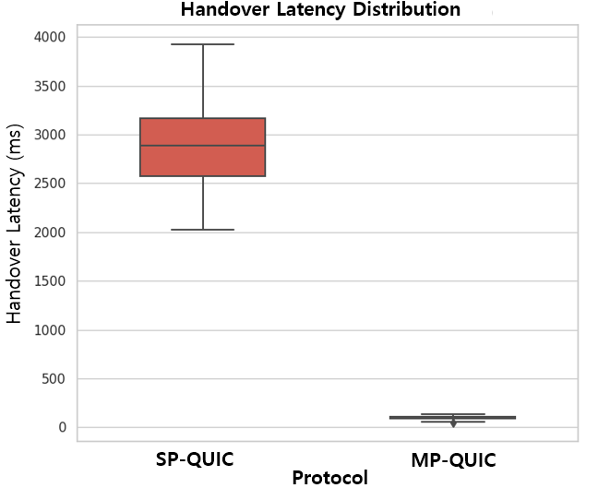
Figure 6: Distribution of handover latency for SP-QUIC and MP-QUIC

From the figure, we see that SP-QUIC suffers from handover delays on the order of several seconds, with significant variance ranging between 2,000 ms and 4,000 ms. This substantial delay is an unavoidable consequence of its reliance on conventional failure detection and subsequent connection re-establishment procedures. In dramatic contrast, MP-QUIC achieves a near-instantaneous handover, with switching latencies consistently below 100 ms. This is accomplished by immediately redirecting traffic to the pre-established 5G Mobile backup path, bypassing the need for recovery protocols entirely. The tightly clustered box plot for MP-QUIC in the figure visually confirms its ability to execute fast, seamless, and low-jitter handovers, which is a critical enabler for mission-critical mobile applications.
To further assess the robustness of each protocol, we introduced controlled cross-traffic on the Wi-Fi path to simulate adverse network conditions. Figure 7 shows the profound impact of network congestion on performance.
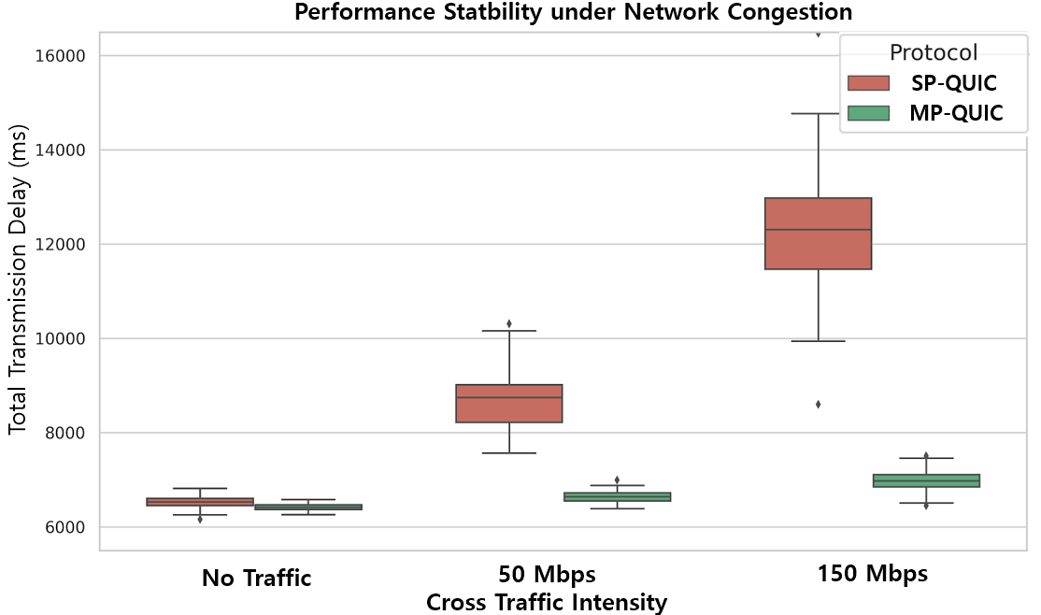
Figure 7: Robustness Analysis of SP-QUIC and MP-QUIC in Congested Network Environments)

Under baseline conditions (no traffic), both protocols exhibit comparable delay profiles. However, as the cross-traffic intensity increases to 50 Mbps and subsequently to 150 Mbps, the performance of SP-QUIC degrades catastrophically. It exhibits severe delay inflation and high variance, with total transmission delays soaring beyond 12,000 ms, rendering it unsuitable for predictable, real-time applications. In contrast, MP-QUIC demonstrates remarkable resilience. By dynamically shifting traffic away from the congested Wi-Fi link, it maintains a highly stable transmission delay of approximately 7,000 ms, even under the most intense 150 Mbps cross-traffic load. These findings conclusively demonstrate that MP-QUIC not only facilitates fast handovers but also provides robust delay stability. This dual capability ensures dependable AMR operation, even within the unpredictable and often congested network environments found in industrial settings.

    - End-to-end and micro-level handover behavior
To comprehensively evaluate the end-to-end impact of handover on application-level performance, we analyzed the throughput dynamics across a complete Wi-Fi disconnection and recovery cycle. Figure 8 illustrates that the SP-QUIC protocol suffers a catastrophic failure during the handover phase, resulting in a total service blackout.
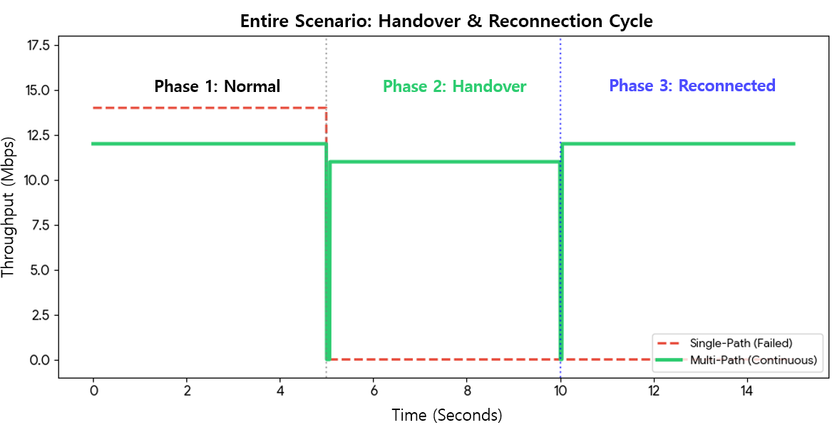
Figure 8: Throughput Behavior of SP-QUIC and MP-QUIC During Wi-Fi Disconnection and Recovery
In the figure we see that the prolonged period of zero throughput persists until the Wi-Fi connection is fully re-established, a recovery process that introduces significant downtime. Such interruptions are critically detrimental to real-time AMR applications, including continuous video monitoring and remote teleoperation, which have stringent requirements for uninterrupted data delivery and cannot tolerate such service gaps. In contrast, MP-QUIC preserves end-to-end service continuity by seamlessly utilizing a pre-established 5G Mobile backup path. Although a brief throughput degradation is observed during the path transition, the transmission never collapses to zero, thereby maintaining continuous delivery throughout the handover period.
To dissect the handover process at a finer timescale, Figure 9 provides a micro-level analysis of throughput dynamics during the Wi-Fi failure and recovery events. This detailed view exposes the internal path-switching mechanisms that are obscured in the broader end-to-end timeline.
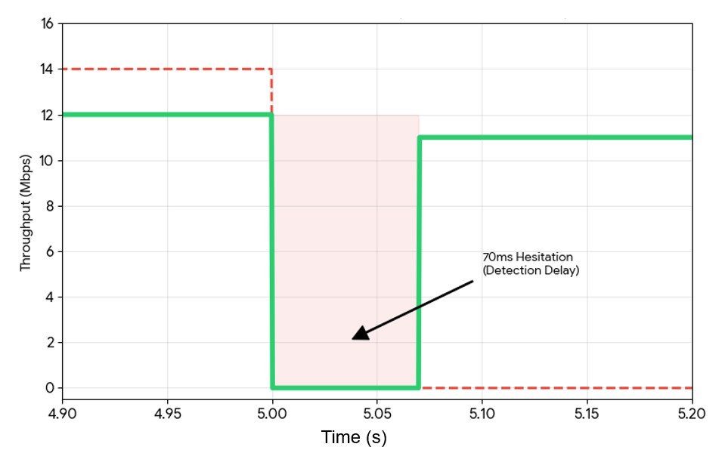
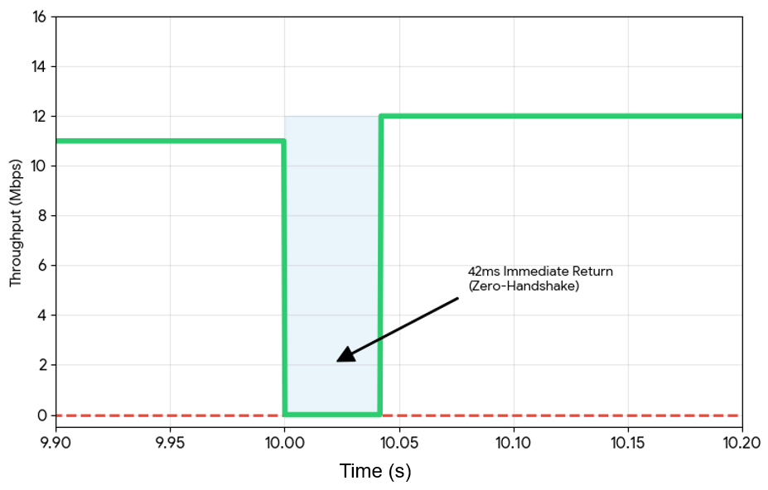

Figure 9: Visualization of MP-QUIC Handover Mechanisms: (a) Short-term Failover Hesitation During Wi-Fi Disconnection and (b) Rapid Path Reactivation During Wi-Fi Recovery)

Upon Wi-Fi failure, the protocol exhibits a brief "hesitation period" of approximately 70 ms before traffic is completely rerouted to the 5G Mobile path. Critically, this delay is attributed to the inherent latency of link degradation detection and the multipath scheduler's decision-making process, not to the time-consuming overhead of connection teardown and re-establishment that plagues single-path protocols.
During the Wi-Fi recovery phase, MP-QUIC demonstrates even greater agility, reactivating the primary Wi-Fi path and resuming traffic flow within a mere 42 ms. It is crucial to note that this process does not involve any connection re-establishment or transport-layer state reset, enabling a seamless migration of traffic back to the preferred, higher-performance path.
These micro-level observations are key: they demonstrate that MP-QUIC effectively transforms a disruptive, connection-level handover into a lightweight, efficient path-scheduling operation. As a result, both macro-level service continuity and micro-level latency stability are simultaneously achieved, providing a clear and direct explanation for the sub-100 ms handover latencies reported in Figure 6.

- Conclusions and Future Works

Guaranteeing uninterrupted, real-time communication for Autonomous Mobile Robots (AMRs) in dynamic industrial environments presents a critical challenge that necessitates robust transport-layer resilience. To overcome the severe transient degradation and service interruptions inherent in conventional SP-QUIC protocols during access point handovers, this paper proposed and empirically validated a handover-adaptive MP-QUIC transmission system. By integrating real-time network sensing, a composite Path Quality Index (PQI), and proactive failover scheduling, our architecture cohesively leverages heterogeneous networks (Wi-Fi and 5G Mobile) to seamlessly shift traffic to a reliable backup path before a complete link failure occurs.
Our real-world testbed evaluations quantitatively demonstrate the superior resilience and stability of this multipath architecture. In scenarios involving Wi-Fi disconnection, where SP-QUIC throughput collapses to zero amidst massive transmission delays exceeding 8,000 ms, our system sustains a continuous throughput of approximately 12.5 Mbps. It successfully contains the total delay to a predictable 6,300–6,500 ms and, most critically, achieves a switching latency of sub-100 ms (70 ~ 118 ms). Furthermore, under severe network congestion (150 Mbps cross-traffic), the system's ability to dynamically avoid the degraded path bounds transmission delay to around 7,000 ms, in contrast to the catastrophic delay inflation (> 12,000 ms) observed with SP-QUIC.
Despite these significant performance gains, we acknowledge certain limitations that point toward future research. The current strategy of maintaining a persistent dual-path state, while effective for near-zero-delay failover, incurs additional power consumption and cellular data usage, which could impact the operational efficiency of resource-constrained AMRs. Moreover, the present PQI formulation relies on predefined static weights and thresholds, which may necessitate manual recalibration for deployment in highly variable radio frequency (RF) environments.
Future work will focus on addressing these constraints. We envision the development of energy-aware multipath scheduling algorithms that intelligently activate the backup interface only when boundary degradation is imminent. Furthermore, integrating advanced machine learning techniques, such as Deep Reinforcement Learning (DRL), to enable autonomous, real-time adaptation of the PQI parameters would significantly enhance the robustness of handover decisions. Such advancements will be instrumental in paving the way for true Ultra-Reliable Low-Latency Communication (URLLC), a cornerstone for next-generation, large-scale AMR fleets operating over private 5G networks augmented with Mobile Edge Computing (MEC).

References
- J. Del Ser and J. L. Martin, “Toward Fully Automated Inspection of Critical Assets Supported by Autonomous Mobile Robots, Vision Sensors, and Artificial Intelligence,” Sensors, vol. 24, no. 12, p. 3721, 2024. DOI: 10.3390/s24123721.
- G. Fragapane, R. de Koster, F. Sgarbossa, and J. O. Strandhagen, “Planning and control of autonomous mobile robots for intralogistics: Literature review and research agenda,” European Journal of Operational Research, vol. 294, no. 2, pp. 405–426, 2021. DOI: 10.1016/j.ejor.2021.01.019.
- K. B. Lee, K. Montgomery, D. Tang, S. Magill, and M. Grieves, “Reliable, High-Performance Wireless Systems for Factory Automation: A Workshop Report,” NIST Interagency/Internal Report (NIST IR) 8317, 2020. DOI: 10.6028/NIST.IR.8317.
- A. Aijaz, "High-Performance Industrial Wireless: Achieving Reliable and Deterministic Connectivity Over IEEE 802.11 WLANs," IEEE Internet of Things Magazine, vol. 3, no. 1, pp. 28-33, 2020. DOI: 10.1109/IOTM.0001.1900075.
- J. Haxhibeqiri, E. A. Jarchlo, I. Moerman, and J. Hoebeke, "Flexible Wi-Fi Communication among Mobile Robots in Indoor Industrial Environments," Mobile Information Systems, vol. 2018, Art. no. 3918302, pp. 1-19, Apr. 2018. DOI: 10.1155/2018/3918302.
- P. Chiavassa, S. Scanzio, G. Cena, F. Wilhelmi, and B. Bellalta, “WifiRoam: An open-source simulator to optimize Wi-Fi handover in industrial networks,” Proc. IEEE Int. Conf. on Emerging Technologies and Factory Automation (ETFA), 2025. DOI: 10.1109/ETFA65518.2025.11205662.
- E. Araújo and B. Miranda, "Mobile Robotics for Throughput Testing in a Reconfigurable Test Environment," Proc. Simpósio Brasileiro de Engenharia de Software (SBES), 2025. DOI: 10.5753/sbes.2025.11613.
- S. Feirer and T. Sauter, "Seamless handover in industrial WLAN using IEEE 802.11k," Proc. 2017 IEEE 26th Int. Symp. on Industrial Electronics (ISIE), Edinburgh, UK, Jun. 2017, pp. 1234–1239. DOI: 10.1109/ISIE.2017.8001421
- A. Mishra, M. Shin, and W. Arbaugh, "An Empirical Analysis of the IEEE 802.11 MAC Layer Handoff Process," ACM SIGCOMM Comput. Commun. Rev., vol. 33, no. 2, pp. 93–102, 2003. DOI: 10.1145/956981.956990.
- J. Iyengar and M. Thomson, “QUIC: A UDP-Based Multiplexed and Secure Transport,” RFC 9000, IETF, May 2021.
- M. Bishop, “HTTP/3,” RFC 9114, IETF, Jun. 2022.
- O. Bonaventure, C. Huitema, M. Kuehlewind, et al., “Managing Multiple Paths for a QUIC Connection,” IETF Internet-Draft, draft-ietf-quic-multipath-21, Mar. 2026.
- W. Yang, L. Cai, S. Shu, J. Pan, and A. Sepahi, "MAMS: Mobility-Aware Multipath Scheduler for MPQUIC," IEEE/ACM Transactions on Networking, vol. 32, no. 4, pp. 3237-3252, Aug. 2024. DOI: 10.1109/TNET.2024.3372990.
- L. Tan, W. Su, Y. Liu, X. Gao, and W. Zhang, “Proactive Connection Migration in QUIC,” in MobiQuitous ’20, 2020, pp. 476–481. DOI: 10.1145/3448891.3448900.
- L. Tan, X. Dong, X. Gao, P. Zhang, W. Su, and J. W.-K. Hong, “Enhancing QUIC Performance in Heterogeneous Networks: A Proactive Connection Migration Approach,” Int. J. Network Manag., vol. 35, no. 5, p. e70022, 2025. DOI: 10.1002/nem.70022.
- E. A. Oyekanlu et al., “A Review of Recent Advances in Automated Guided Vehicle Technologies: Integration Challenges and Research Areas for 5G-Based Smart Manufacturing Applications,” IEEE Access, vol. 8, pp. 202312–202353, 2020. DOI: 10.1109/ACCESS.2020.3035729
- M. Zhang and K. Yu, “Wireless Communication Technologies in Automated Guided Vehicles: Survey and Analysis,” Proc. IECON 2018 – 44th Annu. Conf. IEEE Ind. Electron. Soc., Washington, DC, USA, Oct. 2018. DOI: 10.1109/IECON.2018.8592782
- T. Luong, G. Barros, M. Boshoff, C. Moldovan, D. Schuster, V. Gruhn, and B. Kuhlenkötter, “Investigating the 5G Handover in Autonomous Mobile Robotic Applications,” Proc. 2023 3rd Int. Conf. on Robotics, Automation and Artificial Intelligence (RAAI), Singapore, Dec. 2023. DOI: 10.1109/RAAI59955.2023.10601255
- N. Natmeladze, J. Piteľ, K. Žídek, and V. Romaniuk, “Research on the Implementation of New Communication Technologies to Improve Quality and Stability in Motion Control of Autonomous Mobile Robots,” Technologies, vol. 13, no. 12, p. 556, 2025. DOI: 10.3390/technologies13120556.
- A. Langley et al., "The QUIC Transport Protocol: Design and Internet-Scale Deployment," in Proceedings of the ACM SIGCOMM 2017 Conference, Los Angeles, CA, USA, Aug. 2017, pp. 183–195. DOI: 10.1145/3098822.3098842.
- P.-J. Chen, R.-C. Hsu, T.-C. Yu, and C.-Y. Li, "QUIC-HOA: A Cross-layer, Handover-aware Design for QUIC Connection Migration," Proc. 2024 IEEE Global Communications Conference (GLOBECOM), Cape Town, South Africa, Dec. 2024, pp. 3643-3648. DOI: 10.1109/GLOBECOM52923.2024.10900944.
- S.-Y. Kim and S.-J. Koh, “mQUIC: Use of QUIC for Handover Support with Connection Migration in Wireless/Mobile Networks,” IEEE Commun. Mag., vol. 62, no. 4, pp. 128–134, 2024. DOI: 10.1109/MCOM.023.2300083.
- Y. Xing, K. Xue, Y. Zhang, J. Han, J. Li, D. S. L. Wei, R. Li, Q. Sun, and J. Lu, “A Stream-Aware MPQUIC Scheduler for HTTP Traffic in Mobile Networks,” IEEE Trans. Wireless Commun., vol. 22, no. 4, pp. 2775–2788, 2023. DOI: 10.1109/TWC.2022.3213638.
- T. Viernickel, A. Froemmgen, A. Rizk, B. Koldehofe, and R. Steinmetz, “Multipath QUIC: A Deployable Multipath Transport Protocol,” Proc. 2018 IEEE Int. Conf. on Communications (ICC), Kansas City, MO, USA, May 2018. DOI: 10.1109/ICC.2018.8422951.
- O. Bonaventure, T. Paasch, and G. Detal, “Multipath in the QUIC Transport Protocol,” Internet-Draft, IETF, Work in Progress, 2017.
- J. S. Wejin, J. Badejo, O. Jonathan, and F. Dahunsi, “A Brief Survey on the Experimental Application of MPQUIC Protocol in Data Communication,” Proc. 2022 IEEE 2nd Int. Conf. on Information Technology, Educational and Electrical Engineering (ITED), Abuja, Nigeria, Nov. 2022. DOI: 10.1109/ITED56637.2022.10051479.
- L. Zhang, C.-X. Wang, Z. Zhou, Y. Li, J. Huang, L. Xin, C. Pan, D. Zheng, and X. Wu, “Wireless Channel Measurements and Characterization in Industrial IoT Scenarios,” IEEE Trans. Veh. Technol., vol. 74, no. 2, pp. 2292–2307, 2025. DOI: 10.1109/TVT.2024.3480528.
- I. Varbanov, Y. Paunski, G. Angelov, N. Valchkova, and R. Zahariev, “Latency and Link Speed for Service Robot Control over Mobile Networks,” Proc. 2024 5th Int. Conf. on Communications, Information, Electronic and Energy Systems (CIEES), Veliko Tarnovo, Bulgaria, Nov. 2024. DOI: 10.1109/CIEES62939.2024.10811163.
- H. Iwasawa, T. Kawano, S. Komatsu, T. Tojo, and T. Kuwahara, “Time in Flight Based MPQUIC Scheduler for Remote Monitoring of Autonomous Driving,” Proc. 2025 IEEE 22nd Consumer Communications & Networking Conf. (CCNC), Las Vegas, NV, USA, Jan. 2025. DOI: 10.1109/CCNC54725.2025.10975968.

